A Set of Histology Markers for Esophageal Carcinoma – TCGA Data Mining

Introduction
Esophageal carcinoma is 8th top cancer over the world. In 2020 it caused 604,100 new cases accounting for 3.1 percent of total cancer cases following cervix uteri carcinoma [ref1]. China is an esophageal cancer high risk country. Since 2020 esophageal carcinoma has become the fifth common cancers following liver cancer in China. It has 324,422 new incidence in 2020 and take up to 7.1% of total cancer cases in that year. Incidence rate is more than twice than world average [ref2]. An urged effort is needed to increase the specificity and sensitivity of esophageal carcinoma diagnosis.

The esophageal carcinoma has two common histologic forms: esophageal squamous cell carcinoma (ESCC) and esophageal adenocarcinoma (EAC). They are named after the type of the cells that turn malignant. ESCC forms in the thin, flat cells lining the inside of the esophagus. It is most often found in the upper and middle part of the esophagus. EAC begins in glandular cells. Glandular cells in the lining of the esophagus produce and release fluids such as mucus. It usually form in the lower part of the esophagus near the stomach. The prognosis and treatment for patients with esophageal carcinoma depend on accurate and reliable assessment of histology types and stages since the risk of lymph-node metastasis is correlated with these clinic features. Fox example the risk is close to zero among patients with Barrett’s esophagus who have high-grade dysplasia and is only 1 to 2% among patients with stage I tumors [10.1038/ajg.2012.78].

Nowadays Circulating Tumor Cells (CTC) are under searchlight as novel target for liquid biopsy. Combined with qPCR or single-cell sequencing it has the potential for diagnosing pan-cancer in µl blood. By using proper markers not only could the types of cancer be recognized but the other clinic features such as histology types, prognosis etc. could also be identified. There are many researchers contreating study on prognosis and drug sensitivity. Nonetheless until now there's no solid markers for histology types for esophageal carcinoma. In this study we first used cibersortX tool to screen the differentially expressed genes (DEGs) and clustered the genes into functional modules according to weighted distance by WGCNA. Next ssGSVA was applied on each modules to its calculate the enrichment score. The score was used to train a support vector machine model as a classifier to classify
the unknown cases. Finally the performance of classifier on histology types and prognosis for esophageal carcinoma cases was evaluated and validated on five independent GEO datasets. As results we identified a DNA binding function module associated with histology types and prognosis of esophageal carcinoma patients. It will enables us to identify histology types of esophageal carcinoma.

Methods and Material

Cohort selection

Initially the marker mining work uses TCGA esophageal carcinoma dataset as discovery cohort. The 198 cases with normalized gene expression (pancan normalized) was downloaded from USCS Xena [10.1038/s41587-020-0546-8]. We also used four GEO datasets (GSE155186, GSE165252, GSE44021, GSE112926) to validate the signature of esophageal carcinoma histologic types and one GEO dataset (GSE53625) to validate the correlation between signature and prognosis.

Function modules discovery
CibersortX as a machine learning method was applied to infer cell-type-specific gene profiles. It used normalized expression data and the histology information of each case as input to filter out hundreds of genes that formed linear correlation with the lowest P-value (cutoff 10⁻⁶). The similarity of each pair of genes was calculated and clustered by WGCNA [10.1186/1471-2105-9-559]. The selected function modules in the cluster tree was enriched. The enrichment score for each case was calculated by ssGSEA [10.1073/pnas.0506580102].

Feature selection and validation
We performed a forward step-wise support vector machine model to select a module combination that has the maximum mean F1 score using a customized python script [https://github.com/yaotianran/general_feature_selection]. It started from a single module and add one another for each iteration till a maximum mean F1 score was gain. Meanwhile stratified random cross-validation was applied and repeated twenty times in each iteration to prevent from over-fitting. The final F1 score for each iteration was the average result of all cross-validation repeated results.

Survival analysis and visualization
Using the "survival" R package, the univariate and multivariate Cox regression analyses were performed for analyzing associations of the levels of DNA binding with overall survival. Consequently, powerful prognostic genes were screened out and then risk scores were calculated for all ESCC patients. Based on the median of risk scores, all patients were divided into high- and low- risk group. We used Kaplan–Meier curves to exhibit the association between risk score and overall survival. The log-rank test was employed to test the statistic difference with the significance level p < 0.05. Using the “timeROC” package (version 0.4), the survival receiver operating characteristic curve (ROC) with the area under the curve (AUC) value was visualized. Gene set enrichment analysis (GSEA) was carried out to evaluate associations of immune pathways with the TME-related risk score. p < 0.05 indicated statistical significance.

Results

Cohort information
The mean-normalized gene RNA expression data for TCGA esophageal cancer was downloaded from UCSC Xena datahub [10.1038/s41587-020-0546-8]. It will used as discovery cohort and compared with esophageal cancer data from other sources. The cohort contains 196 cases but only 181 of them have histology diagnosis information, which are composed of 87 EAC and 94 ESCC. The other clinical information was displayed in table 1. Four GEO datasets (GSE155186, GSE165252, GSE44021, GSE112926) were used as validation cohort. Totally it contains EAC 128 cases and 139 ESCC cases.
Table 1 Clinical features of patients with esophageal carcinoma in TCGA
Clinical features | Count (%) (n = 181)
Status
Alive | 106 (58.6)
Dead | 75 (41.4)
Gender
Male | 156 (86.2)
Female | 25 (13.8)
Survival records
Recorded | 125  (Min. 0 month  Median 13.0 month  Max 123.8 month)
Not Recorded | 56
Stage
I | 18 (9.9)
II | 77 (42.5)
III | 54 (29.8)
IV | 9 (5.0)
Not recorded | 23 (12.7)
Histology
EAC | 87 (48.1)
ESCC | 94 (51.9)
Pharmaceutical
Yes | 52 (28.7)
No | 129 (71.3)
Radiation
Yes | 62 (34.2)
No | 119 (65.8)

Gene set signatures for EAC and ESCC
First we feed the TCGA normalized expression data and sample types to CibersortX [10.1038/s41587-019-0114-2] as reference to generate the signature matrix. CibersortX uses unsupervised machine learning to infer the cell-type- or sample-type specific signature genesets. Total 808 genes as signatures were identified. Hereby we considered a gene as a down-regulated gene if it expresses lower in EAC cases than ESCC otherwise as an up-regulated gene. The down-regulated and up-regulated genes in the signature were further clustered into different modules by WGCNA distance to narrow down the signature space capacity. The function of the modules could be enriched simply by Fisher's exact test or GSEA into different catalogs by g:Profiler online tool. Figure 1 and supplementary table 1 only shows the most important function modules enriched into GO database [10.1093/nar/gkaa1113] as genesets that could be further used in ssGSVA analysis. The down-regulated genes were clearly more differentiated accomplished. The largest branches - "epidermis development" was classified into extracellular region and intermediate filament based on cellular components. The other significant modules include DNA binding and cell differentiation. The function of up-regulated genes were mainly about digestion but they sparsely distributed signature space and formed no clear modules. The only exception was brush border assembly indicating the genes most likely have fluctuated expression in brush border membrane and microvillus region.
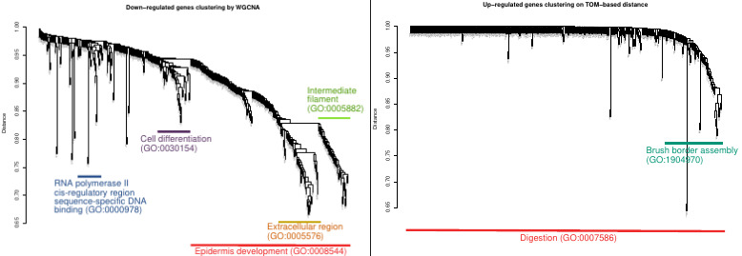
Figure 1 The annotated tree clusters based weighted expression pattern for regulated genes. Left: down-regulated genes Right: up-regulated genes

Next we used ssGSVA to estimates variation of each function module over GEO validation cohort in an unsupervised manner. It calculates sample-wise gene set enrichment scores as a function of genes inside and outside the gene set. Hereby each function module in WGCNA contain a gene set. Due to the limited amounts of gene sets we were able to enumerate the score of all the gene set combinations on different classifiers (supplementary table 2). Although adding gene sets into signature space could increase sample resolution and brought better sensitivity and specificity users had to use more probes and more expensive array. To gain the better balance of cost and performance finally we chose the DNA binding gene set as a single signature from five gene sets candidates (DNA binding, cell differentiation, extracellular region, intermediate filament and brush border assembly). Linear kernel support vector machine or SVM classifier was applied to fit and predict the enrichment score on GEO validation cohort to evaluate the resolution on EAC and ESCC cases. Meanwhile the same method was also employed for TCGA discovery cohort as a positive control. The figure 2 indicates the performance of the SVC model on distinguishing two types of esophageal cancer. When DNA binding module were used the AUC was approximately 0.961 and p-value (Fisher's Exact Test) was less then 10E-26 (figure 2 b and d). It is natural that the classifier has better performance on TCGA discovery cohort as reference than third-party GEO data. Nonetheless it still has a sensitivity and specificity of larger than 0.9 (Table 2).
Table 2 Performance of SVM classifier on discovery and validation cohort
Cohort | Sensitivity | Specificity | AUC | F1 Score
Discovery (TCGA) | 92.5% | 97.7% | 0.983 | 0.951
Validation (GEO) | 90.6% | 94.5% | 0.961 | 0.926

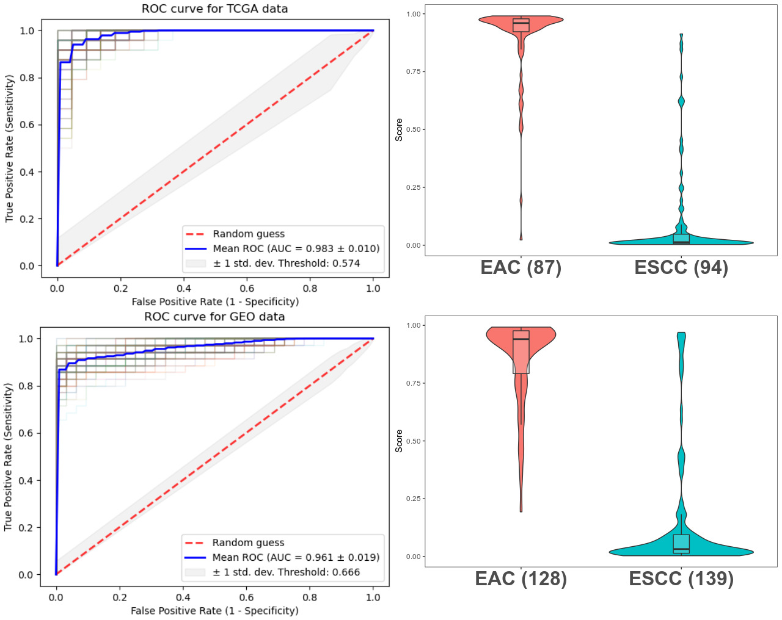
Figure 2 The ROC and classification score of DNA binding module for ESCC and EAC cases. Top: TCGA cohort . Bottom: four GEO datasets

DNA binding can acts as a solo stage-irrelevant prognosis factor
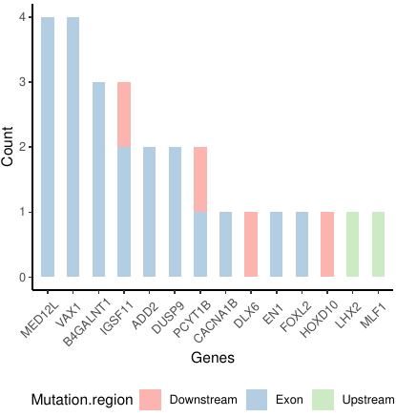
Zheng et al. obtained an immune cell atlas (TME signatures) of ESCC consisting of CD4, CD8 T and NK cells etc. [10.1038/s41467-020-20019-0]. The atlas contributes to the immune suppressive state and disease progression altering potential immuno-suppression in the TME. In addition the author also found a turquoise module was positively correlated with the monocyte clusters. This module was also acclaimed to be significantly associated with the survival of patients with ESCC. The atlas was composed of 12 modules 459 genes including a turquoise module consisting of 50 genes (supplementary table 3). In order to elucidate the TME variation between EAC and ESCC cases and the performance on predicting prognosis of esophageal cancer we compared the enrich score on same esophageal cancer cases using TME signatures and DNA binding signatures. For TME signatures the EAC significantly has higher enrichment score than ESCC cases revealing two types of esophageal cancer show distinct immune state. Although the TME slightly outperformed DNA binding signature in sensitivity (95.0% vs. 90.6%) and specificity (96.9% vs. 94.5%) (Supplementary table 1). 459 genes are much more then 22 genes in DNA binding signature. That means that a larger array or whole transcriptome sequencing has to be employed to get solid results from TME signatures.

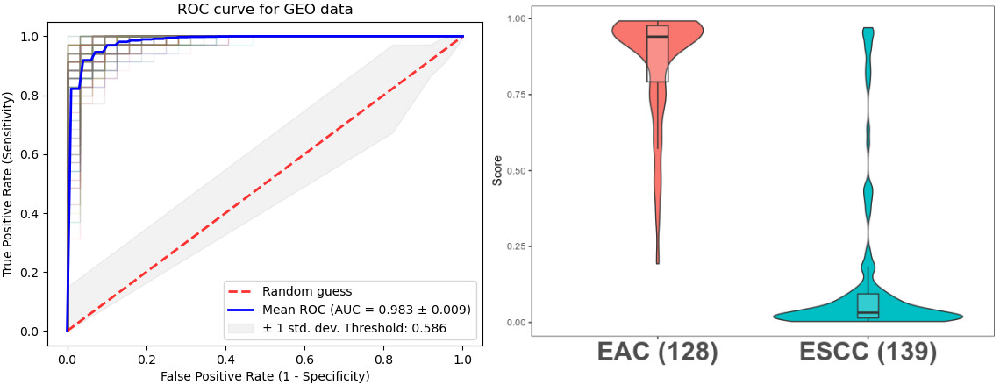
Figure 3 The ROC and classification score of TME signatures for ESCC and EAC cases.

The survival function module in TME signature containing six genes (IFNGR1, IFNGR2, IDO1, IL10, CD163, CD274) was supposed to be associated with survival. Interestingly we found very weak correlation (log-rank test p value 0.19) between ssGSVA score of six-gene survival module and survival time for ESCC cases in our TCGA discovery cohort (data not shown). On the contrary a much more solid association between DNA binding signature score and survival was identified for esophageal cancer cases on TCGA discovery cohort and it was further validated in an independent GEO dataset (GSE53625) (Figure 4). A greater enrichment score for DNA binding signature leaded to a poor prognosis. Multivariate Cox Regression reveals that DNA binding signature has no correlation with cancer stage, histology and therapy. (supplementary table 4) It suggests that DNA binding signature had a potential to be a solo stage-irrelevant prognosis indicator for esophageal cancer.
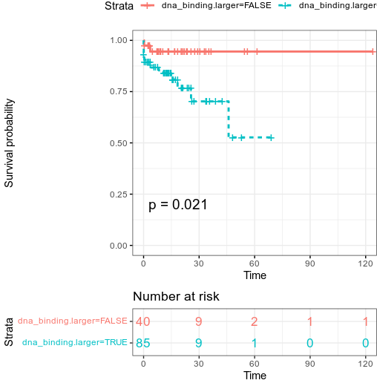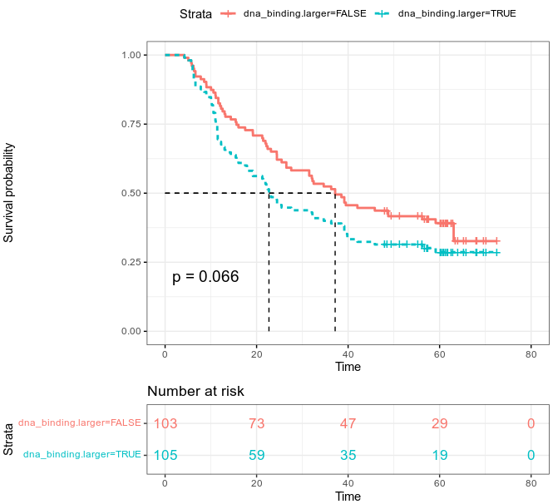
Figure 4
The Kaplan-Meier curves of DNA binding module as stage-irrelevant prognosis factor on Left: TCGA cohort Right: GEO dataset (GSE53625)

Discussion
Previously many researchers focused on prediction for the survival esophageal carcinoma patients and had revealed a variety of marker associated with prognosis of esophageal carcinoma. Those makers could be mainly classified into three types: lncRNA markers (BC200[10.2147/OTT.S99401], loc285194[10.1016/j.prp.2019.04.018], RP5-1172N10.2 and other six RNA [10.1038/s41598-018-27307-2], MALAT1[10.1136/bmjopen-2015-008653], H19[10.1016/j.prp.2019.152638]), protein markers (p53 and other nine protein[10.1016/S0003-4975(01)02838-7], stathmin[10.7314/APJCP.2014.15.8.3613], CD133[10.3892/mco.2015.651], nucleostemin[10.1111/j.1349-7006.2011.02142.x], p97[10.1158/1078-0432.CCR-0723-03], KLF17[PMC4637651], HMGB3[PMC4348853]), cytology markers (M2 macrophages[PMC5400603]).
But so far there is no study on the markers for the histology types of esophageal carcinoma.

In this study we first used cibersortX [10.1038/s41587-019-0114-2] tool to extract a superset of 808 DEGs between ESCC and EAC from 181 TCGA esophageal carcinoma cases. A hierarchical tree was built according to expression pattern distance by WGCNA. The clusters from the tree clearly showed that there are alteration from five function modules between two types of esophageal carcinoma. They are DNA binding, cell differentiation, extracellular region, intermediate filament and brush border assembly. These findings confirm the role of different DEGs and function modules in the extracted gene superset. The five modules was further evaluated by ssGSVA and SVM model (Supplementary table 2). We found that although the combination of all five modules as features would maximize the performance of the classifier model. It has limited or minimal effect to increase the total specificity and sensitivity comparing to the solo DNA binding alone. Finally only DNA binding module was used as a histology marker of esophageal carcinoma. It can achieve a sensitivity of 92.5% and a specificity of 97.7% on TCGA discovery cohort (Table 2). The DNA binding module contains 22 genes including FOXD3, Homeobox family genes and DUSP9 etc. (Supplementary table 1). Some of them have been studied separately and been identified relative to tumor development. For example FOXD3 gene codes Forkhead Box protein FoxD3 which is a transcriptional regulators mainly expressed in embryonic stem cells. It is generally down-regulated during early endoderm formation [10.1073/pnas.062041099] and is a major regulator of the developmental potential of embryonic stem cells and epiblast cells [10.1016/j.stem.2015.10.003]. Some researchers found that the expression level of the FOXD3 gene could be regulated by hypermethylation in ovarian cancer samples making it a potential cancer marker [10.1186/s12935-019-0755-8]. Three Homeobox family genes (HOXD10, HOXD11, HOXD13) all play an important role in cell differentiation, dysregulation of which will lead to hepatocellular carcinoma[10.1186/s13148-017-0412-9], colon cancer[10.1186/s12964-018-0316-0], genital abnormalities, and limb abnormalities[10.1242/dev.00936, 10.1038/jhg.2011.84]. DUSP9 (Dual-specificity phosphatase 9) belongs to the dual-specificity protein phosphatase subfamily. It is a strong negative regulator of transcription factor activating kinases (ERK, JNK and p38) in the mitogen-activated protein kinase (MAPK) pathways [10.3892/or.2015.3998]. It is founded down-regulated and methylated in colorectal cancer [10.3389/fonc.2020.547011] and cenal cell carcinoma. DLX6-AS1 as lncRNA was found to promotes neuroblastoma progression [10.1186/s12935-019-0968-x] while MLF1 is associated with acute myeloid leukemia and myelodysplastic syndrome [10.1038/sj.leu.2401897]. To further validate the marker we also tested it in a validation cohort mixed by four independent GEO datasets. It has a sensitivity of 90.6% and specificity of 94.5% and can give an AUC value of 0.961 in ROC analysis. This is quite the same as the performance in discovery cohort which means the single DNA binding module combined with SVC model regulation did not overfit the TCGA data and make them capable as histology marker between EAC and ESCC.

Next we compared our DNA binding module and the turquoise module of TME signatures, which is assumed to be associated with progression-free survival in ESCC as well as in cervical squamous cell carcinoma and lung squamous cell carcinoma and serve as a prognostic biomarker in ESCC and squamous cell carcinoma in other tissues. Unfortunately we fail to observer a strong correlation (log-rank test p value 0.19) between survival and ssGSVA enrichment score for ESCC cases in TCGA cohort. Meanwhile we identified that our DNA binding module was enriched in
ESCC cases with poor prognosis in TCGA data and was validated in dataset GSE53625 (log-rank test p value 0.005). The association between DNA binding module and poor prognosis was probably because it contains the genes related to embryonic stem cells differentiation. Hence the their expression varies greatly in different cell types or cell cycle. These genes make the module a potential prognosis marker in liquid biopsy.

